From the NEO Portal I click on the MDG Hub button to bring up the following:
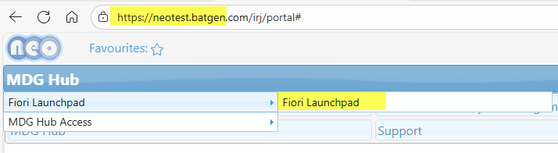
After clicking the Fiori Launchpad above, I get the following blank menu screen
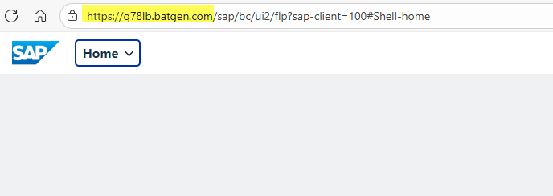
It should look like this which is my QA equivalent Fiori Launchpad menu
